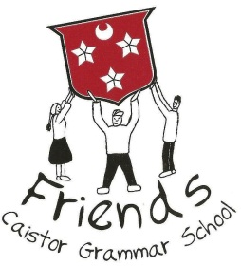

Registered Charity Number 1069393

14th October 2016
Dear Parents
The Friends of Caistor Grammar School are organising a Quiz Evening on Friday November 11th at 7pm in the Old Hall.
Teams can be up to six. The price is £7 for each individual and this will include a Fish and Chip supper from our local supplier. There will also be a fully licensed bar available. We do hope that you will attend as it promises to be a good evening. All money raised will go directly to the School.
Please complete the proforma below and place it in an envelope with cheques made payable to Friends of Caistor Grammar School and return it to the School Office by Wednesday 9th November. Tickets will be returned via your child
Yours sincerely

Tracey Edwards
Chair of the Friends
……………………………………………………………………………………………………………………………………………………………
Quiz Evening- Friday 11th November
Please return in an envelope to the School Office by Wednesday 9th November
Name of parent ……………………………………………………………
Number of tickets …………………. @ £7 per ticket. Total £ …..……………
Please make cheques payable to “Friends of Caistor Grammar School”
Please tick one of the following
- I have organised my own team.

- I would like to join a team.
Name of the student …………………………………………………. Form ………………..

