Classical Civilisation - Preparation for A-Level

Welcome to Classics! You will study THREE modules over the course of the two-year A-Level. We will provide text books and literary texts at the start of Year 12. However, if you wish to purchase your own copies of the text books in advance, then please find details below:
MODULE 1: THE WORLD OF THE HERO
This consists of an in-depth study of:
• Homer’s Odyssey
• Virgil’s Aeneid
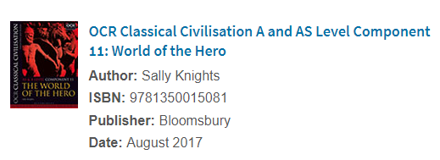
WHAT YOU CAN DO TO PREPARE FOR MODULE 1:
(1) It is not necessary to have read the literary texts e.g. Homer’s Odyssey or Virgil’s Aeneid, before the course begins. However, I would highly recommend reading Homer’s Iliad, which is not studied but which is referred to quite often. You might not have time once the course starts.
You can use any translation of the text but here are two recommendations
• Homer, ‘Iliad’ translated by E.V. Rieu, revised translation by D.C.H. Rieu (Penguin)
• ‘Homer: The Iliad – The Killing Fields of Troy’, translated by A.S. Kline, online at http://www.poetryintranslation.com

(2) You might like to watch a summary on Youtube of the epics we do study, in order to get an idea of the plot outline:
Homer’s Odyssey https://www.youtube.com/watch?v=A-3rHQ70Pag
Virgil’s Aeneid https://www.youtube.com/watch?v=QRruBVFXjnY

MODULE 2: CULTURE AND THE ARTS
Greek Theatre - the study of visual and material culture combined with the study of Tragedy and Comedy in translation.
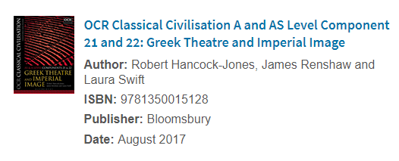
WHAT YOU CAN DO TO PREPARE FOR MODULE 2:
Visual/Audio
• Introduction to Greek Drama/Theatre
https://www.youtube.com/watch?v=VeTeK9kvxyo&feature=youtu.be
• Brief summary of Euripides’ Bacchae
https://www.youtube.com/watch?v=lOPOw6MWDZM
• Brief summary of Oedipus the King
https://www.youtube.com/watch?v=6IfTDtuPLeg
• Comedy and Aristophanes
https://www.ted.com/talks/mark_robinson_why_is_aristophanes_called_the_father_of_comedy/transcript?language=en

COMPONENT 3: BELIEFS AND IDEAS
• Greek Religion or • Democracy and the Athenians
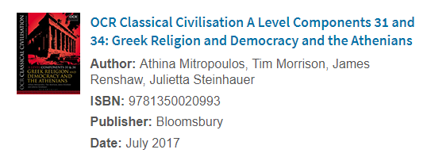
WHAT YOU CAN DO TO PREPARE FOR MODULE 3:
(1) Visual
• https://ed.ted.com/lessons/a-day-in-the-life-of-an-ancient-athenian-robert-garland
• https://ed.ted.com/lessons/what-did-democracy-really-mean-in-athens-melissa-schwartzberg
• https://www.youtube.com/watch?v=lZZgTilriB4

WHAT YOU CAN DO TO PREPARE IN GENERAL:
The best preparation you can make for Classical Civilisation A-Level is to enjoy reading, watching or listening to anything Classics related. This will broaden your general knowledge and appreciation of what is a varied subject. Here are some suggestions:
(1) Visual
• https://www.bbc.co.uk/iplayer/episodes/p017b9xg/the-grandeur-that-was-rome
• Gods and Myths https://www.youtube.com/watch?v=gJqxnUBacd4
• History of Ancient Greece https://www.youtube.com/watch?v=mzGVpkYiJ9w
• History of Ancient Rome https://www.youtube.com/watch?v=SGJtItq0cpg&list=PLEb6sGT7oD8FTGtHNYG4LLolaK5cTq07F

(2) Audio
Click on the following links and you will find a variety of audio discussions. Listen to the ones which interest you.
Radio 4: In our Times
• The Greek World https://www.bbc.co.uk/programmes/p01h9vvk
• The Roman World https://www.bbc.co.uk/programmes/p01hb0h8
• Greek Myths https://www.bbc.co.uk/programmes/b0093z1k
• The Muses https://www.bbc.co.uk/programmes/b07bft7v

Natalie Haynes stands up for the classics.
https://www.bbc.co.uk/programmes/b077x8pc/episodes/player
(3) Reading
Perhaps a little beneath you now, but Rick Riordan’s novels provide an excellent overall knowledge of Greek myths. There are also many other fiction novels base on ancient Greece or Rome.
There is a wealth of information on Ancient Greece and Rome available on Youtube, Ted-Talks and the BBC (and other TV channels) so have fun browsing and expand your knowledge!

