Biology at Caistor Grammar School.
Preparation for September.
Course: OCR Biology A (H420)
Many students find the jump from GCSE to AS level difficult. This pack is designed to aid that transition in Biology.
Start preparing for the course by downloading a copy of the Specification from:
https://www.ocr.org.uk/Images/171736-specification-accredited-a-level-gce-biology-a-h420.pdf
This is a useful page to print off and place at the front of your Biology notes.

Module 1 is continuously assessed throughout Year 12 and 13. We aim to cover Modules 2,3 & 4 in Year 12 and Modules 5 & 6 in Year 13.
Summer reading
A more detailed reading list will be issued in September, in the meantime reading and working through the CGP Headstart book would be excellent preparation for your course.

A copy of the Head Start to AS Biology revision guide
from CGP that covers topics linking GCSE to A Level
biology. You will be tested on similar content in
September.
• Publisher: CGP
• Price: Around £5
• ISBN: 978 1 78294 279 5
Text books
We will issue you with a text book in September but can recommend that you also buy this book. Our current Y12 and Y13 students rate it very highly. It is not an essential purchase though. You may be able to find them second hand.

Any queries? Email: fiona.cooke@caistorgrammar.com
allison.clark@caistorgrammar.com
tara.taylor@caistorgrammar.com
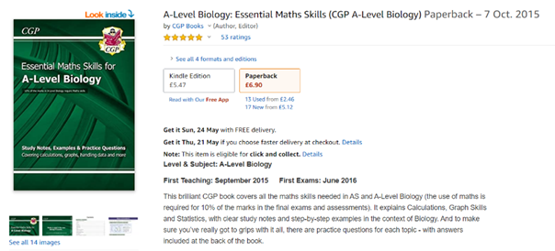
There is a surprisingly large amount of Maths utilised in Biology and if you know that your Maths skills are not very strong then we highly recommend buying this CGP book to assist you throughout the course.

Biology is the study of living things, but not just animals and plants. You’ll also
learn about the molecules that make living things work, the cells that they’re
made from, the systems within plants and animals, and the interconnections
between organisms.
Biology is different from physics and chemistry, in that living things don’t
always do what you expect them to do. You can’t test one organism and
assume all the rest will be the same, so you’ll learn about the statistical
analysis behind making claims.
At first, you may find the jump in demand from GCSE a little daunting, but if
you follow the tips and advice in this guide, you’ll soon adapt.
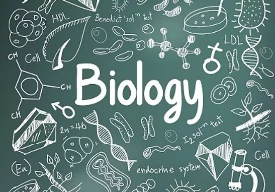
We recommend you keep this pack somewhere safe, as you may like to refer
to the information in it throughout your studies.
Why study A-level Biology?
Biology A-level will give you the skills to make connections and associations
with all living things around you. Biology literally means the study of life - and if
that’s not important, what is? Being such a broad topic, you’re bound to find a
specific area of interest, plus it opens the door to a fantastic range of
interesting careers.
Many people use an AS or A-level in Biology in their future studies or work.
Even if you don’t decide to work in biology, studying it still develops useful and
transferable skills for other careers. You’ll develop research, problem solving
and analytical skills, alongside teamwork and communication. Universities and
business regard all of these very highly.

Possible degrees and career options
According to bestcourse4me.com, the top seven degree courses taken by students who have A-level Biology are:
• Biology
• Psychology
• Sport and exercise science
• Medicine
• Anatomy
• Physiology and pathology pharmacology
• Toxicology and pharmacy chemistry.
This list is by no means exhaustive. Biology can prove useful for a wide variety
of degree courses. For more details, go to the bestcourse4me.com, or UCAS.
Studying Biology at A-level or degree opens up all sorts of career opportunities,
such as:
• doctor
• clinical molecular geneticist
• nature conservation officer
• pharmacologist
• research scientist
• vet
• secondary school teacher
• marine biologist
• dentist.
Places to go for help
1. The OCR website is a great place to start
The Biology webpages are aimed at teachers, but you may find them useful
too. Information includes:
• The specification – this explains exactly what you need to learn for
your exams.
• Practice exam papers
• Lists of command words and subject specific vocabulary – so you
understand the words to use in exams
• Practical handbooks explain the practical work you need to know
• Past papers and mark schemes from the old specifications. Some
questions won’t be relevant to the new AS and A-level, so please
check with your teacher.
• Maths skills support
2. Royal Society of Biology
“A single unified voice for biology”. They work with everyone from government
policy makers to students, as well as universities and researchers studying
biology. Their website includes a dedicated student section. Have a look at
rsb.org.uk
3. The Student Room
Join the A-level Biology forums and share thoughts and ideas with other
students if you’re stuck with your independent learning. Just be very careful
not to share any details about your assessments, there are serious
consequences if you’re caught cheating. Visit thestudentroom.co.uk
4. Keep up to date with Scientific events in the news

Lectures on current science topics
1. Go to www.ted.com and type Biology into the search engine. You will find interesting lectures on current topics i.e. tissue engineering (making synthetic organs).
2. Itunes –Youtube

Magazines and subscriptions
1. The Wellcome Trust (www.wellcome.ac.uk/) a fantastic, free online resource offering regular publications of the newest scientific discoveries as well as a multitude of excellent on line learning resources
2. New Scientist
3. Society of Biology
4. Biological Sciences Review (Philip Allan Publishers): Specially written articles on recent research in the biological sciences, central to A-level topics, as well as grade-boosting advice from examiners
5. Scientific American
6. Focus magazine
Film/TV/internet
1. Look out for documentaries related to your subject choice, ie Panorama, Horizon, Richard Attenborough
2. A fantastic resource, in particular for animations, is YouTube.
3. Biology podcasts
4. BBC.co.uk/science: covers up to date topical science topic
Reading list – to get you started
1. The selfish gene – by Richard Dawkins
2. How we live and why we die – by Lewis Wolpert
3. The man who mistook his wife for a hat – by Oliver Sacks
4. Life Ascending – the great inventions of evolution – by Nick Lane
5. Power, sex and suicide - mitochondria and the meaning of life - by Nick Lane
6. Advice to a young scientist - by Peter Medawar.

