ENGLISH LITERATURE AT A LEVEL: Y12
AQA: English Literature A (7712)

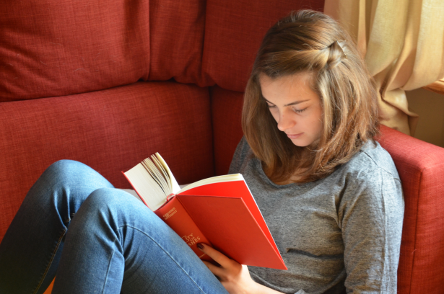
A Level English Literature Students beginning Year 12 in September 2020 will be required to purchase, and make a first reading of, the following texts for Paper 1: Love through the Ages:
The Great Gatsby (F Scott Fitzgerald): Wordsworth Classics ISBN: 9781853260414
Othello (Shakespeare): Third Edition/Series Arden Shakespeare ISBN: 9781903436455
To complement your reading and research, the English Department also recommends:
Othello: York Notes for A level (Rebecca Warne) ISBN: 9781447982258
The Great Gatsby: York Notes for A Level (Julian Cowley) ISBN: 9781447982289
Study and Revise for A Level AQA Anthology: Love Poetry through the Ages
(Luke McBratney/Hodder Education) ISBN: 9781471853838
(You will receive your copy of the AQA anthology in September. In the meantime you can download poems from the AQA website- we will focus on the pre 20th century section)
First and foremost, we want you to enjoy reading the set texts for the first part of this course over the Summer but we do advise that you buy or recycle a sturdy Lever Arch file to compile background notes on context (AO3), form, structure and language (AO2) once you’ve got to grips with the plot.

The English Department is committed to developing your love of literature beyond the syllabus. For a limited period, in response to the school closures caused by Coronavirus, the National Theatre is offering username and password access to the National Theatre Collection. A whole range of plays can be accessed remotely ensuring students studying from home can still watch them.
Access details are: https://www.dramaonlinelibrary.com
Username: 1Ns+9Yq)n%
Password: 0AaY2Fb(n+

A level Content Overview at a Glance
Autumn and Spring Term

Section A/B: CLOSED BOOK
Section C: OPEN

Paper 1: Love through the Ages
- You will study three texts: Othello and the Great Gatsby, together with an AQA anthology of love poetry.
- In the Exam: Section A – you will answer one passage-based question on Othello; Section B – a compulsory essay question based on two unseen poems; Section C – one essay question (from a choice of two) that links the AQA anthology with ‘The Great Gatsby’.

Please contact the Head of English if you have any queries: briony.mcneilly@caistorgrammar.com
Spring and Summer Term

Summer Term

Paper 2: Texts in Shared Contexts (World War One)
- You will study three texts (one poetry: ‘Up the Line to Death’, one prose: ‘A Long Long Way’, and one drama: ‘Journey’s End’) and practise analysis of unseen prose material about World War One.
- In the Exam: Section A – you will answer one question from a choice of two on the poetry anthology ‘Up the line to Death’; Section B – you will answer one compulsory question on an extract of unseen literary prose; Section C – you will answer one question that compares ‘A Long Long Way’ to ‘Journey’s End’.
word count: 2500
Sections A/B/C: OPEN
Coursework (Non-Examined Assessment): Texts Across Time
- You will write a comparative critical study of two equally weighted texts by two different authors (one of these texts must be pre 1900) that are sanctioned by the examination board.

